Java程序设计实验报告

学号： 120L022109
姓名： 李世轩
专业： 计算机与电子通信
班级： 120L0221

哈尔滨工业大学

实验报告七

一、实验内容
题目：基于类继承和多态，在Shapes程序的基础上编写一个画图程序，在已有Shape、Line、Circle、Rectangle、Triangle的基础上增加和两种新的类，并支持图形面积和周长的计算（Line面积设置为0）。
提示：
- 考虑下图中类的继承关系是否合理？如果不合理应该如何改进？
- 为类Sharp增加抽象函数getArea(), getPerimeter()，在子类中实现它们。

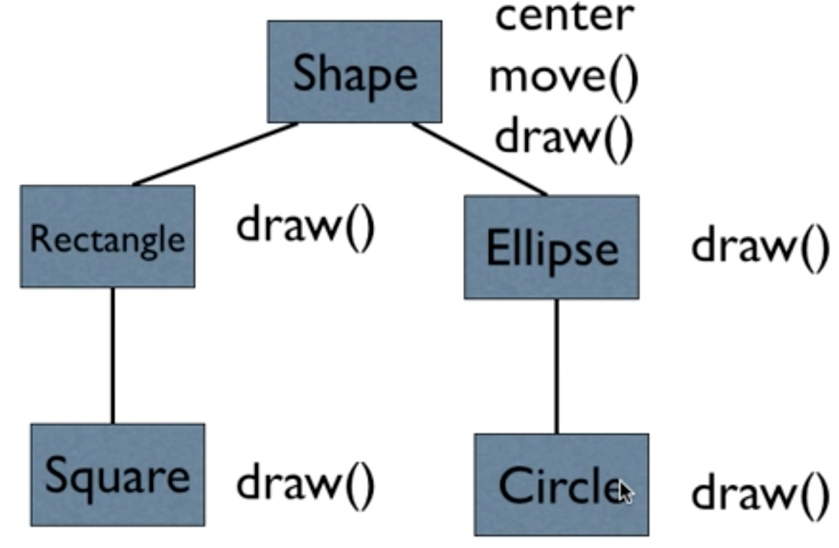

- 从数学上，正方形是一种特殊的矩形。但是，从程序实现上考虑，正方形只要一个边长，而矩形可以从正方形继承后再增加一个边长成员变量。另一方面来说，如果正方形从矩形继承，那么就会出现冗余的第二个边长变量。

二、实验运行结果
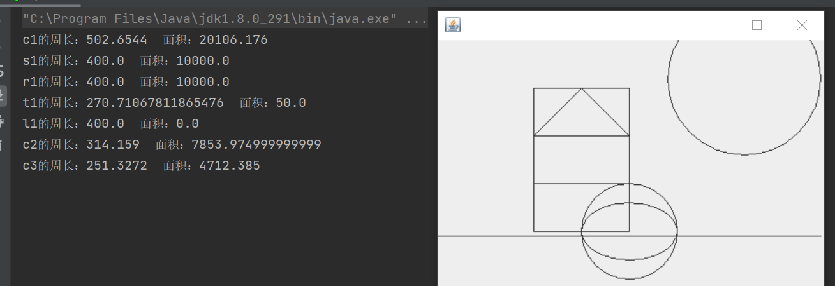
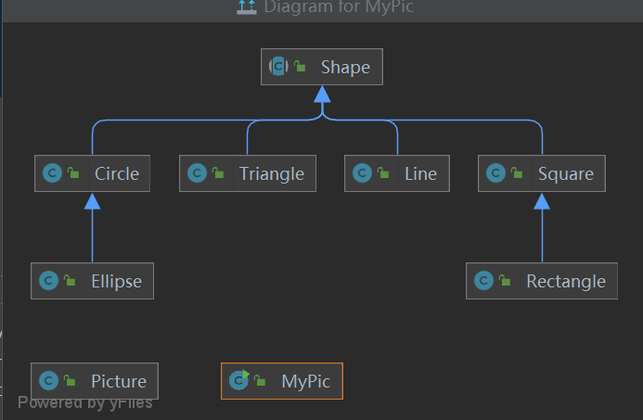

三、程序源代码

package seventh;

import java.awt.Graphics;

public abstract class Shape {

public abstract void draw(Graphics g);
public abstract double getArea();
public abstract double getPerimeter();
}

package seventh;

import java.awt.Graphics;

/**
* 三角形
*/
public class Triangle extends Shape {
private int[] x = new int[3];
private int[] y = new int[3];

public Triangle(int x1, int y1, int x2, int y2, int x3, int y3)
{
x[0] = x1; x[1] = x2; x[2] = x3;
y[0] = y1; y[1] = y2; y[2] = y3;
}

@Override
public void draw(Graphics g) {
g.drawPolygon(x, y, x.length);
}

@Override
public double getArea() {
int[] ab = {x[1]-x[0],y[1]-y[0]};
int[] ac = {x[2]-x[0],y[2]-y[0]};
// double s = 0.5*(ac[0]*ab[1]-ac[1]*ab[0]);
// if (s<0)return -s;
// return s;
return Math. abs (0.5*(ac[0]*ab[1]-ac[1]*ab[0]));
}

@Override
public double getPerimeter() {
int[] ab = {x[1]-x[0],y[1]-y[0]};
int[] ac = {x[2]-x[0],y[2]-y[0]};
int[] bc = {x[2]-x[1],y[2]-y[1]};
double a =Math.sqrt(bc[0]*bc[0]+bc[1]*bc[1]);
double b =Math.sqrt(ac[0]*ac[0]+ac[1]*ac[1]);
double c =Math.sqrt(ab[0]*ab[0]+ab[1]*ab[1]);
return a+b+c;
}

}

package seventh;

import java.awt.Graphics;

/**
* 线
*/
public class Line extends Shape {
private int x1;
private int y1;
private int x2;
private int y2;

public Line(int x1, int y1, int x2, int y2)
{
this.x1 = x1; this.y1 = y1;
this.x2 = x2; this.y2 = y2;
}

@Override
public void draw(Graphics g) {
g.drawLine(x1, y1, x2, y2);
}

@Override
public double getArea() {
return 0;
}

@Override
public double getPerimeter() {
return Math.sqrt((x2-x1)*(x2-x1)+(y2-y1)*(y2-y1));
}

}

package seventh;

import java.awt.Graphics;

/**
* 圆形
*/
public class Circle extends Shape {
public static final double PAI = 3.14159;
private int x;
private int y;
private int radius;

public Circle(int x, int y, int radius)
{
this.x = x;
this.y = y;
this.radius = radius;
}
@Override
public void draw(Graphics g) {
g.drawOval(x-radius, y-radius, radius*2, radius*2);
}

@Override
public double getArea() {
return PAI * radius * radius;
}

@Override
public double getPerimeter() {
return 2* PAI * radius;
}

public int getX() {
return x;
}

public void setX(int x) {
this.x = x;
}

public int getY() {
return y;
}

public void setY(int y) {
this.y = y;
}

public int getRadius() {
return radius;
}

public void setRadius(int radius) {
this.radius = radius;
}
}

package seventh;

import java.awt.*;

/**
* 椭圆
*/
public class Ellipse extends Circle{
private int minor;

public Ellipse(int x, int y, int axis,int minorAxis) {
super(x, y, axis);
this.minor = minorAxis;
}
@Override
public void draw(Graphics g) {
int x = super.getX();
int y = super.getY();
int axis = super.getRadius();
g.drawOval(x-axis, y-minor, axis*2, minor*2);
}

@Override
public double getArea() {
int axis = super.getRadius();
return PAI * axis * minor;
}

@Override
public double getPerimeter() {
int axis = super.getRadius();
int a=0,b=0;
if(axis>minor){
a=axis;
b=minor;
}else {
a=minor;
b=axis;
}
double Q = a+b;
double h = ((a-b)/(a+b)*(a-b)/(a+b));
double m = 22/(7*PAI)-1;
double n =Math.pow((a-b)/a,33.679);
return PAI*Q*(1+(3*h/(10+Math.sqrt(4-3*h))))*(1+m*n);
}
}

package seventh;

import java.awt.*;

/**
* 正方形
*/
public class Square extends Shape{
private int x;
private int y;
private int width;

public Square(int x, int y, int width) {
this.x = x;
this.y = y;
this.width = width;
}

@Override
public void draw(Graphics g) {
g.drawRect(x,y,width,width);
}

@Override
public double getArea() {
return width*width;
}

@Override
public double getPerimeter() {
return 4*width;
}

public int getX() {
return x;
}

public void setX(int x) {
this.x = x;
}

public int getY() {
return y;
}

public void setY(int y) {
this.y = y;
}

public int getWidth() {
return width;
}

public void setWidth(int width) {
this.width = width;
}
}

package seventh;

import java.awt.Graphics;

/**
* 矩形
*/
public class Rectangle extends Square {
private int height;

public Rectangle(int x, int y, int width, int height) {
super(x,y,width);
this.height = height;
}

@Override
public void draw(Graphics g) {
g.drawRect(super.getX(), super.getY(),super.getWidth(), height);
}
@Override
public double getArea() {
return super.getWidth()*height;
}

@Override
public double getPerimeter() {
return 2*(super.getWidth()+height);
}
}

package seventh;

import java.awt.Graphics;
import java.util.ArrayList;

import javax.swing.JFrame;
import javax.swing.JPanel;

/**
* 面板
*/
public class Picture extends JFrame {
private static final long serialVersionUID = 1L;
private int width;
private int height;

private ArrayList<Shape> listShape = new ArrayList<Shape>();

private class ShapesPanel extends JPanel {
private static final long serialVersionUID = 1L;

@Override
protected void paintComponent(Graphics g) {
super.paintComponent(g);
for ( Shape s : listShape )
{
s.draw(g);
}
}

}

public void add(Shape s)
{
listShape.add(s);
}

public Picture(int width, int height)
{
add(new ShapesPanel());
this.setDefaultCloseOperation(EXIT_ON_CLOSE);
this.width = width;
this.height = height;
}

public void draw()
{
setLocationRelativeTo(null);
setSize(width, height);
setVisible(true);
}
}

package seventh;

/**
* 测试程序
*/
public class MyPic {
public static void main(String[] args)
{
Picture pic = new Picture(420,300);
Circle c1 = new Circle(320,40,80);
Square s1 = new Square(100, 100, 100);
Rectangle r1 = new Rectangle(100, 50, 100, 100);
Triangle t1 = new Triangle(100, 100, 200, 100, 150, 50);
Line l1 = new Line(0,205,400,205);
Circle c2 = new Circle(200,200,50);
Ellipse c3 = new Ellipse(200,200,50,30);
pic.add(c1);
System.out.println("c1的周长："+c1.getPerimeter()+" 面积："+c1.getArea());
pic.add(s1);
System.out.println("s1的周长："+s1.getPerimeter()+" 面积："+s1.getArea());
pic.add(r1);
System.out.println("r1的周长："+r1.getPerimeter()+" 面积："+r1.getArea());
pic.add(t1);
System.out.println("t1的周长："+t1.getPerimeter()+" 面积："+t1.getArea());
pic.add(l1);
System.out.println("l1的周长："+l1.getPerimeter()+" 面积："+l1.getArea());
pic.add(c2);
System.out.println("c2的周长："+c2.getPerimeter()+" 面积："+c2.getArea());
pic.add(c3);
System.out.println("c3的周长："+c3.getPerimeter()+" 面积："+c3.getArea());
pic.draw();
}
}

